Suggested table report and form layouts for CAMPER.

The screen shots below show the default table reports, filters, and edit form layouts that the JUICE team found most useful to support the content management workflow in CAMPER.

In a few tables, there are fields that were part of the preliminary JUICE design and are no longer used. These are hidden from the reports and forms.

The default table reports for the module, modulette, and ancillary_files tables do not include all of the key information and functions related to tags, uploading images, and publishing images and files. For those tables, the JUICE constructed separate reports, which are listed with each table’s information below.

modules 2

modulette_groups 6

modulettes 8

tabs 12

tracks 14

widget_instances 16

files 18

ancillary_files 20

rubrics 23

modulette_rubrics 25

projects 26

module_instances 28

modulette_sub-competencies 30

audio_maps 32

widgets 34

# modules

## Default table report

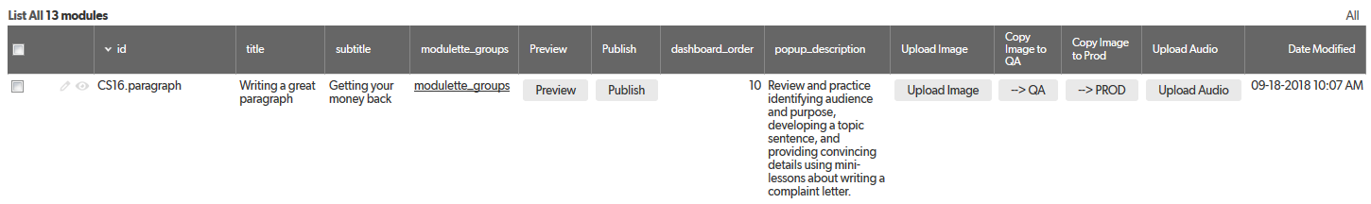

## Recommended filters

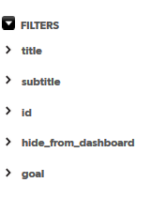

## Edit form

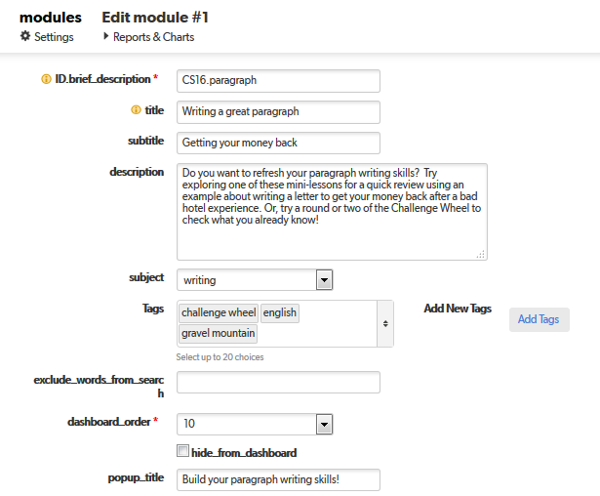

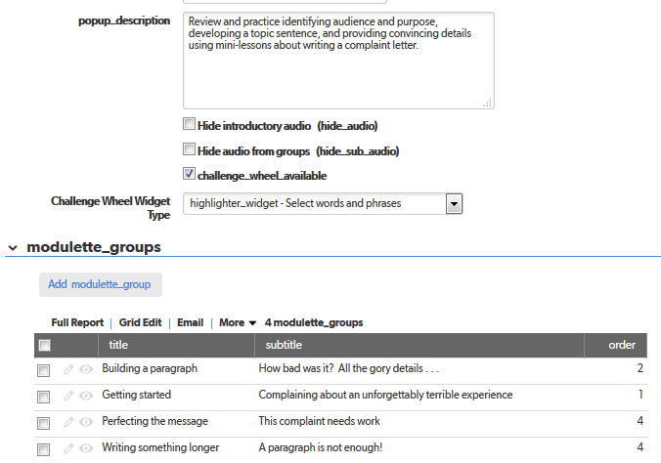

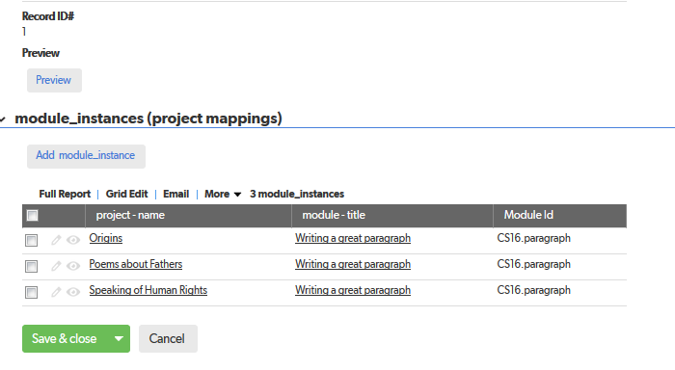

## Extra reports

These reports include features and data that are not displayed in the Default table report.

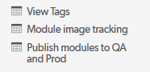

# modulette_groups

## Default table report



## Recommended filters

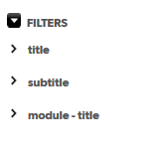

## Edit form

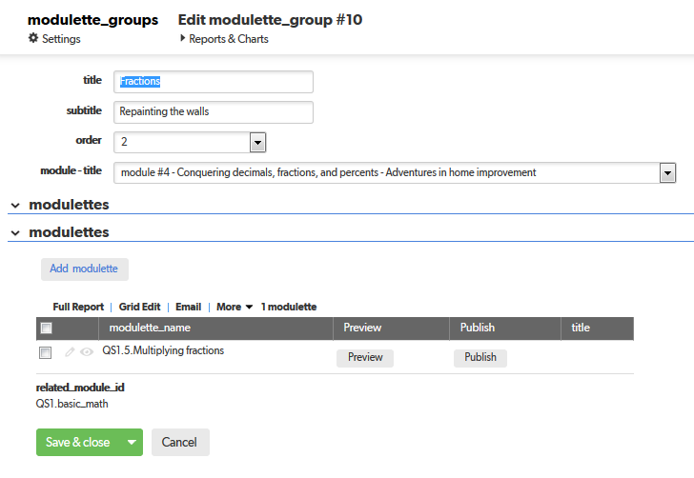

## 

# modulettes

## Default table report





## Recommended filters

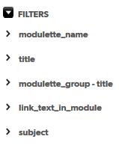

## Edit form

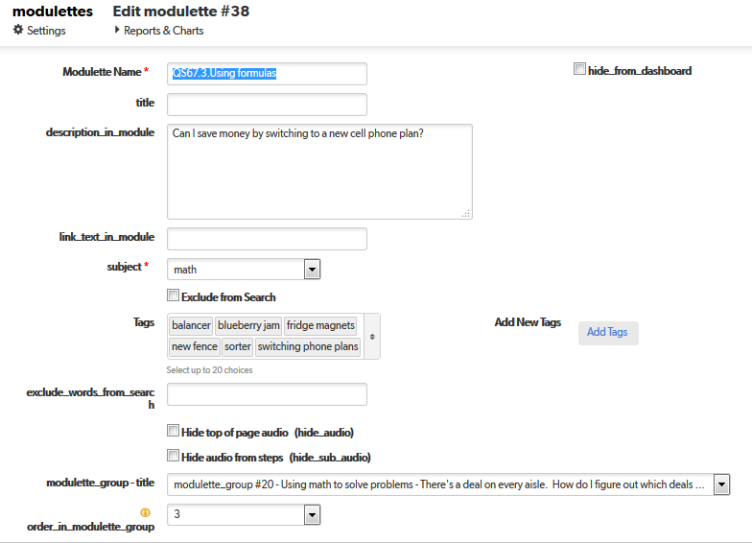

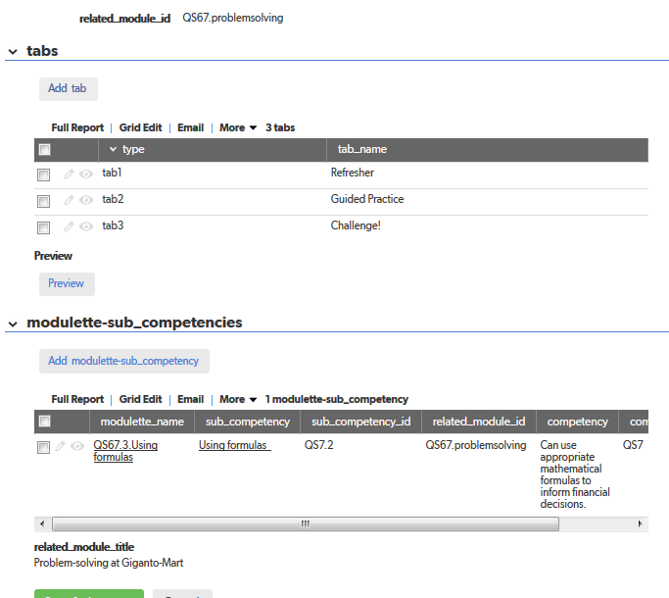

## Extra reports

These reports include features and data that are not displayed in the Default table report.

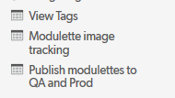

# tabs

## Default table report



## Recommended filters

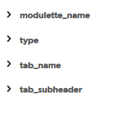

## Edit form

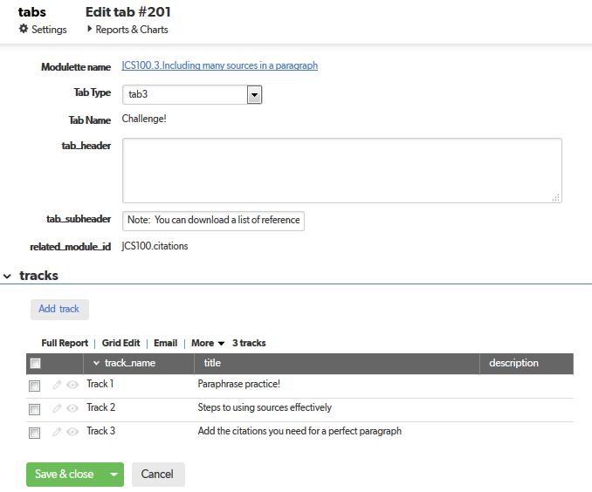

# tracks

## Default table report



## Recommended filters

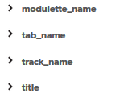

## Edit form

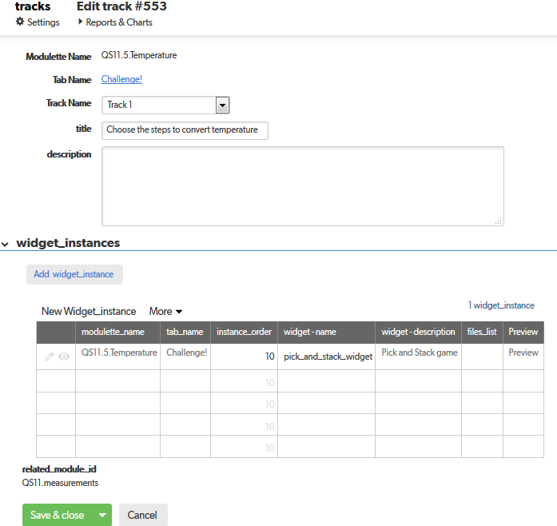

# widget_instances

## Default table report



## Recommended filters

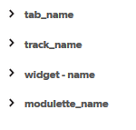

## Edit form

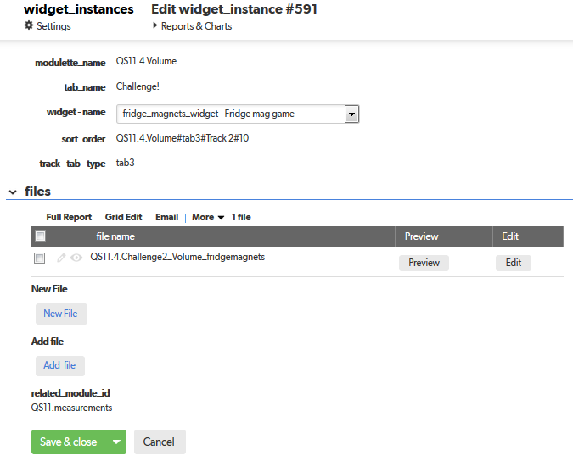

# files

## Default table report



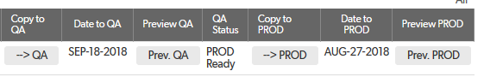

## Recommended filters

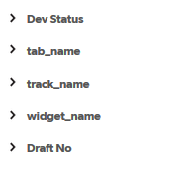

## Edit form

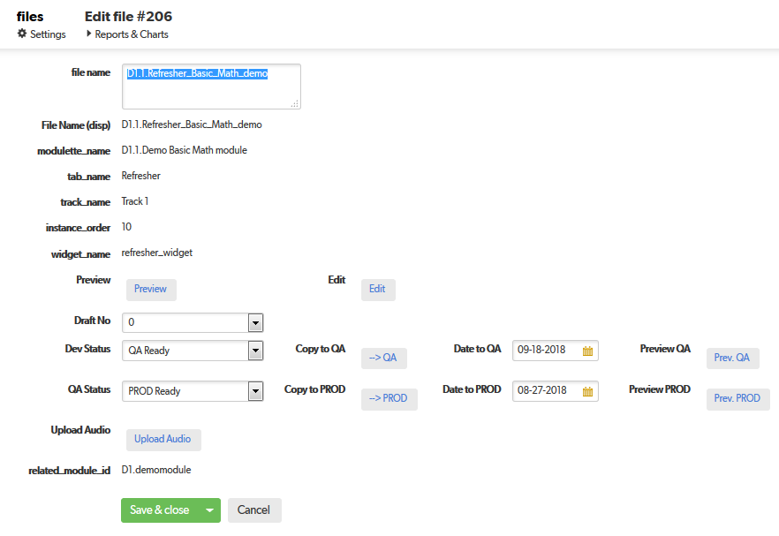

# ancillary_files

## Default table report



## Recommended filters

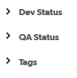

## Edit form

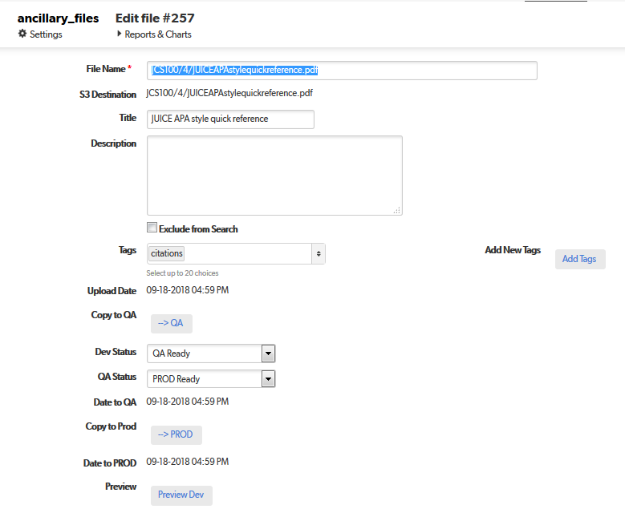

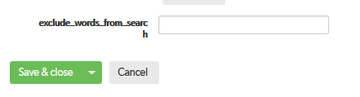

## Extra reports

These reports include features and data that are not displayed in the Default table report.

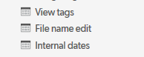

# rubrics

## Default table report



## Recommended filters

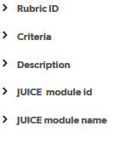

## Edit form

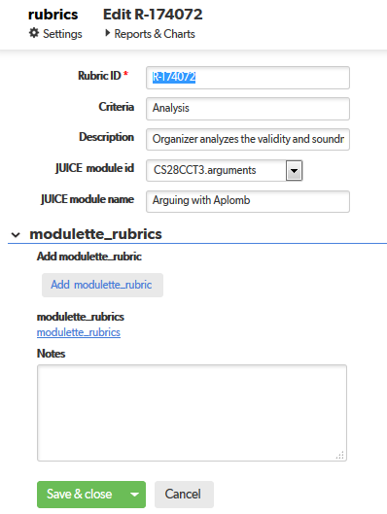

# modulette_rubrics

## Default table report



## Recommended filters

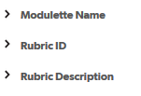

## Edit form

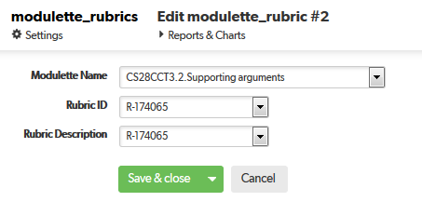

# projects

## Default table report

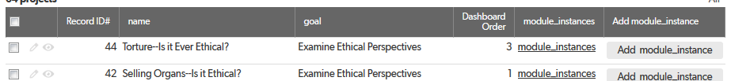

## Recommended filters

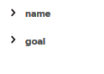

## Edit form

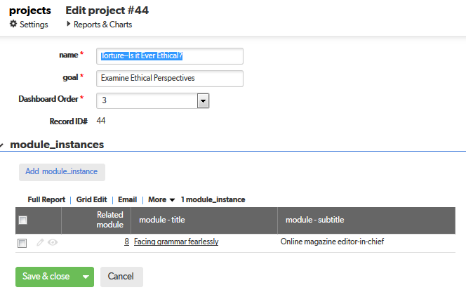

# module_instances

## Default ttable report

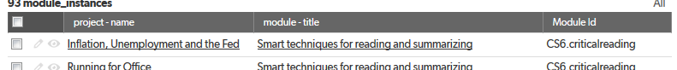

## Recommended filters

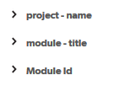

## Edit form

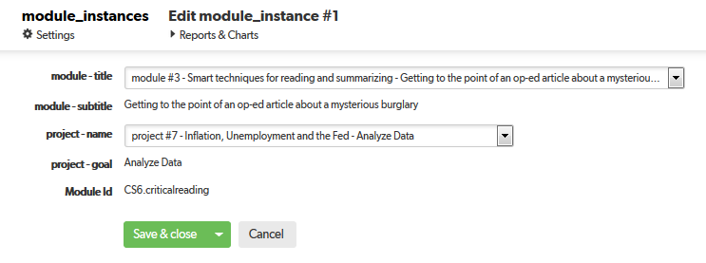

# modulette_sub-competencies

## Default table report



## Recommended filters

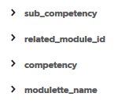

## Edit form

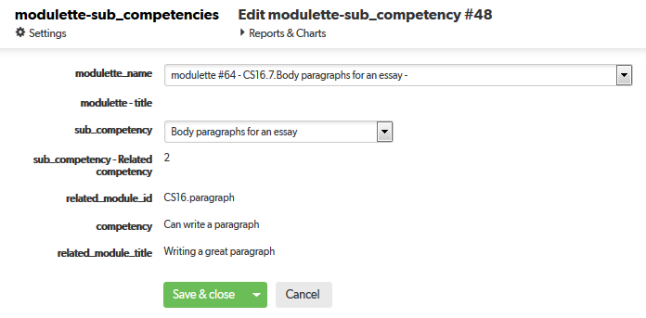

# audio_maps

## Default table report

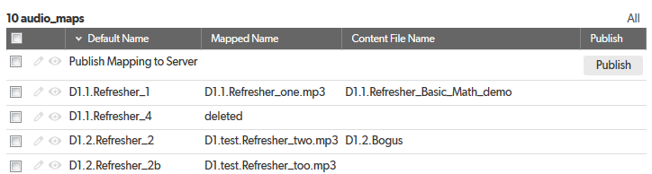

## Recommended filters

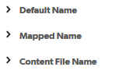

## Edit form

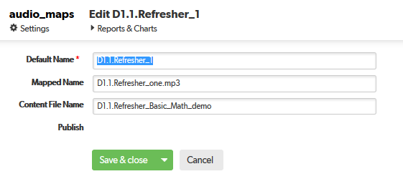

# widgets

## Default table report



## Recommended filters



## Edit form

